**Use Dashboard Nodes For Creating UI (Web App)**

|  |  |
| --- | --- |
| Team ID | PNT2022TMID537346 |
| Project Name | Signs with Smart Connectivity for better Road Safety. |
| Team Leader | Prakash.k |
| Team Members | Keerthi Abinow.G  Sabarishwaran.K  Praveen.T.V |
| Mentor | Anupama j Nair |

**Creating the Node-RED Nodes :**

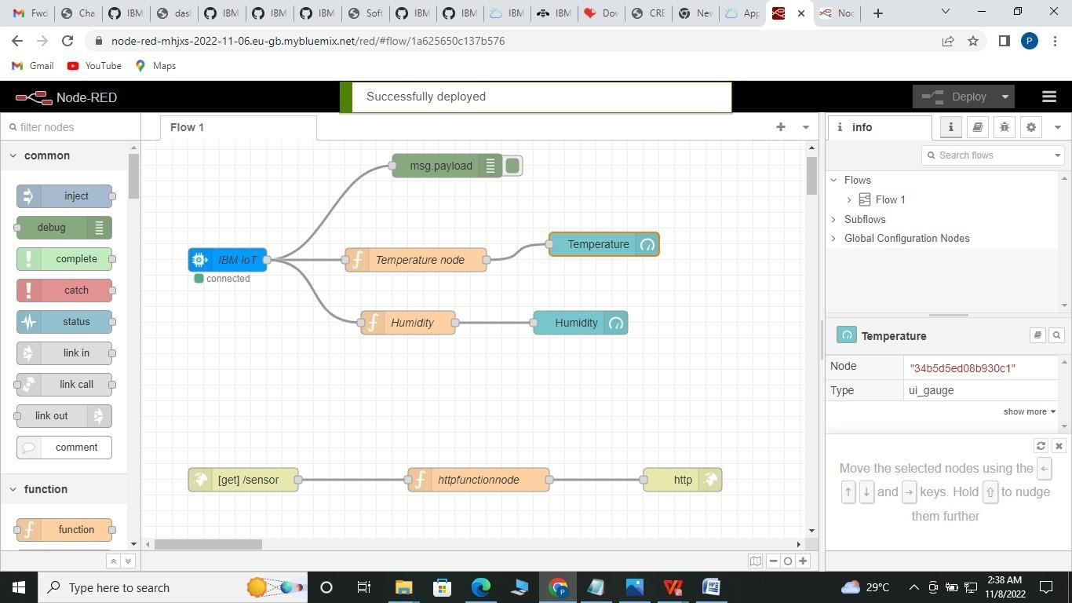

**Dashboard NODE For create UI(web app) :**

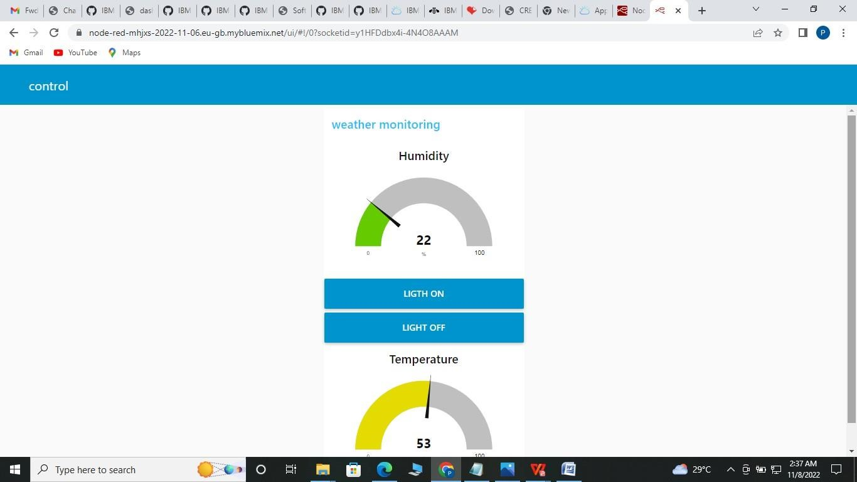

**UI For Device :**

[https://node-red-mhjxs-2022-11-06.eug](https://node-red-mhjxs-2022-11-06.eu/)b.mybluemix.net/ui/#!socketid=y1HFDdbx 4i-

4N4O8AAAM